Boolean (Logical) Operators & Functions

FUN FACT:

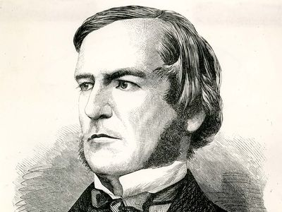

Boolean Algebra is a branch of mathematics that deals with binary variables.
Invented by British Mathematician and Philosopher George Boole and laid out in his 1854 book titled An Investigation of the Laws of Thought where he argued that logical reasoning could be expressed through mathematical equations, which was a radical idea at the time. His work was controversial because it claimed that logic and reason could be organized and calculated, rather than being a purely philosophical idea.
His work in inventing Boolean Algebra is part of the foundation for modern computing.
Logical Operators

Operator | Description | Example | Returns
= | Equal to | =A1=10 | TRUE if A1 is 10
<> | Not equal to | =A1<>10 | TRUE if A1 is not 10
> | Greater than | =A1>10 | TRUE if A1 > 10
< | Less than | =A1<10 | TRUE if A1 < 10
>= | Greater than or equal to | =A1>=10 | TRUE if A1 is 10 or more
<= | Less than or equal to | =A1<=10 | TRUE if A1 is 10 or less

Logical Functions

Function | Description | Example | Returns
AND() | TRUE if all conditions are true | =AND(A1>0, B1<100) | TRUE or FALSE
OR() | TRUE if any condition is true | =OR(A1="Yes", B1="Y") | TRUE or FALSE
NOT() | Reverses a logical value | =NOT(A1=10) | TRUE if A1 ≠ 10

Honorable mentions:
While not a Logical Function itself, the IF() function heavily relies on Logical Functions and Operators.

IF() | Returns one value if condition is true, another if false | =IF(A1>10, "Yes", "No") | "Yes" or "No", etc.

